Title or Task: | ADI 113 Convert Drawings in Illustrator
Description: | Create and Draw a scene

Files Required
Suitable for Classes: | AIT • Multimedia • Cert II IT • Cert II Bus
Area: | Technology & Enterprise
Teacher: | Mr Peter Faulks
Timeline | 1 lesson

Date Due:

Task Brief:

Outcomes:


Items highlighted in yellow are tasks for you to complete
Items in Blue italics are help tips

Illustrator (CS3)

You might want to convert one of your drawings or a drawn logo into illustrator so you can colour it.

Here are the steps to do this

Open Illustrator use A4 size if not certain of image dimensions
Open or Place the drawing i.e. ADI101-Colour-Me-In.jpg

Click on your image using the black selection tool, go to Object>Image Trace> (Live Trace (CS3)), Make.

What you are doing here is converting a pixel-based image into a vector.
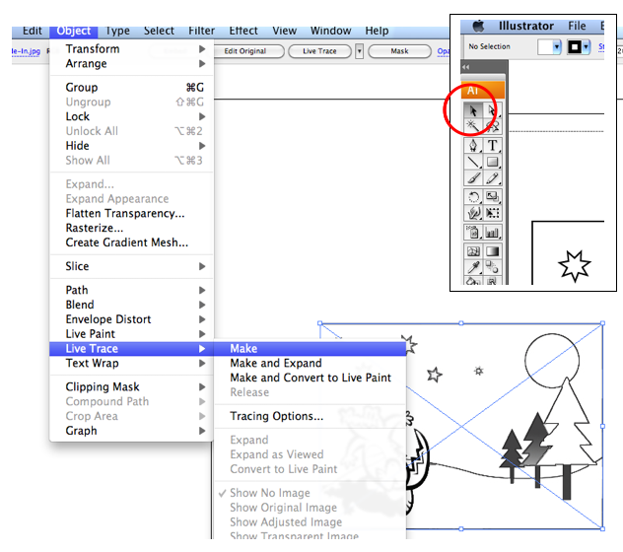

At the top toolbar under Preset you have different levels, I have chosen the Technical Drawing setting as I find it the most accurate but you can experiment with all settings and just undo (Edit>Undo).

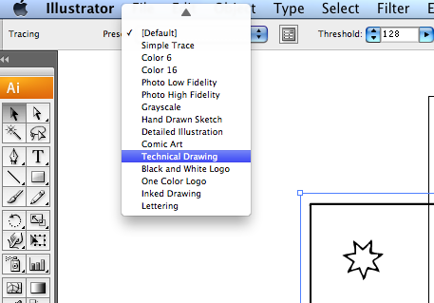
Once you are happy go to Object>Image Trace>Expand. This unlocks the vector but you will find that Illustrator will always group all the elements together, so you will need to highlight the entire image and ungroup – I find I need to ungroup several times to ungroup the image. Then are now ready to edit.

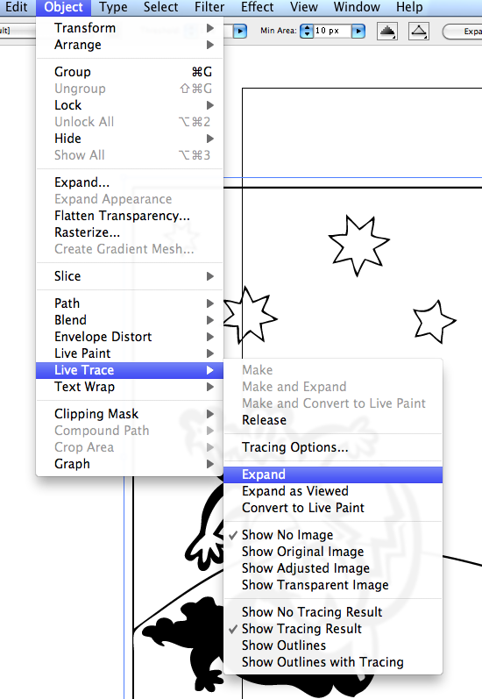

You may need to ungroup several times but you will then have each element avaialble to work on.

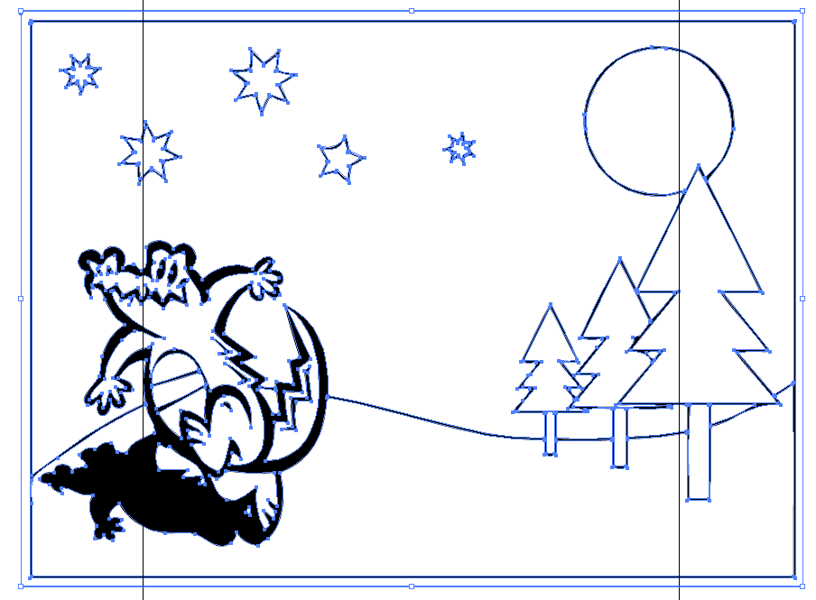

Ungrouped work on the following

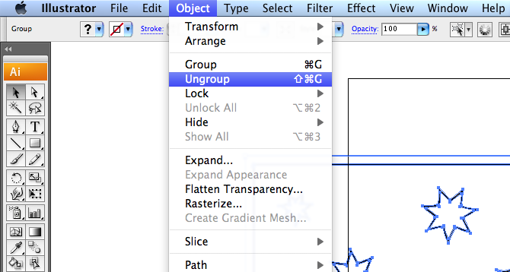

Using the image below convert to a colour scene using a range of colours

Convert the gray scale image so that you can use colours
Edit – Edit Colours – Convert to CMYK

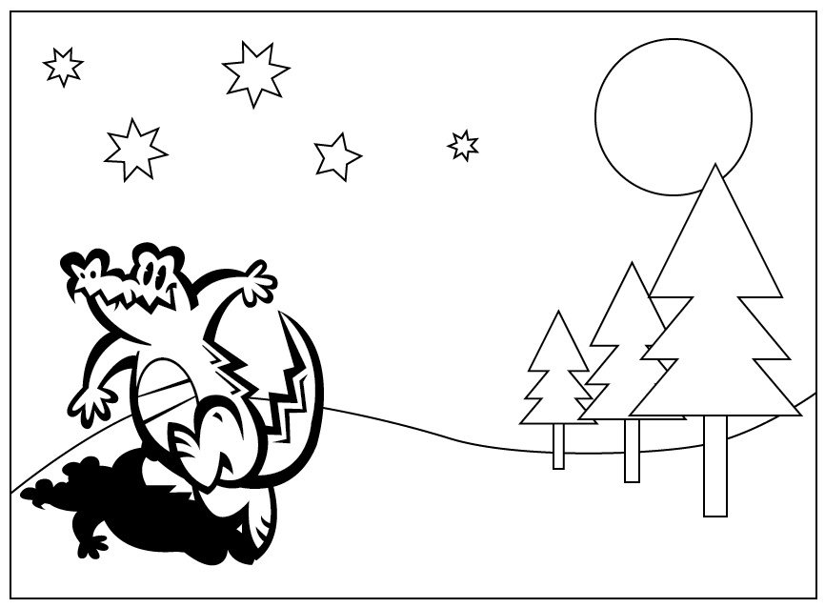

Change the document setup to suit your image, I changed to landscape.

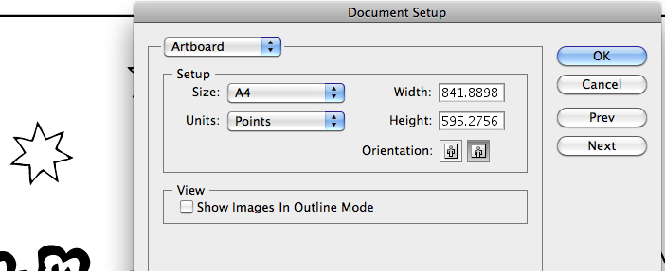

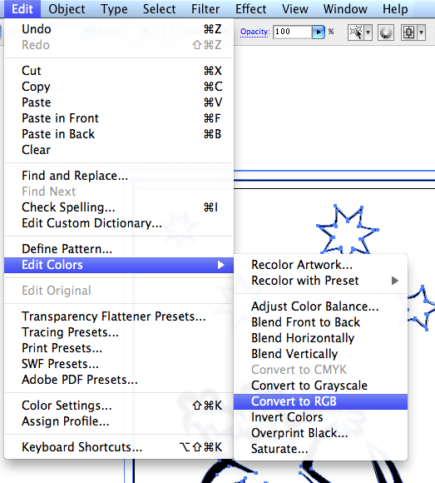

Recolour the picture completely
Make the corcodile green
Add a nice sun with blue sky and
Colour some stars and
Create a gradien colour for the trees


Need help just ask
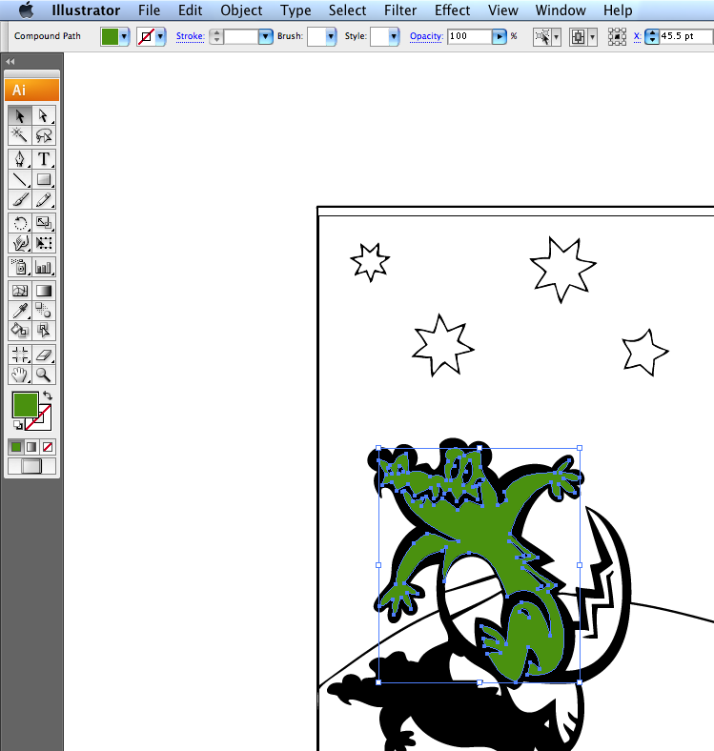

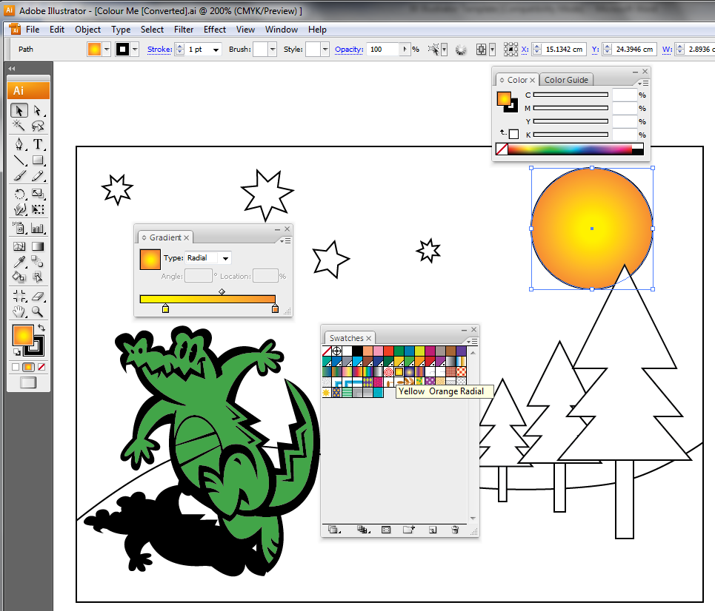

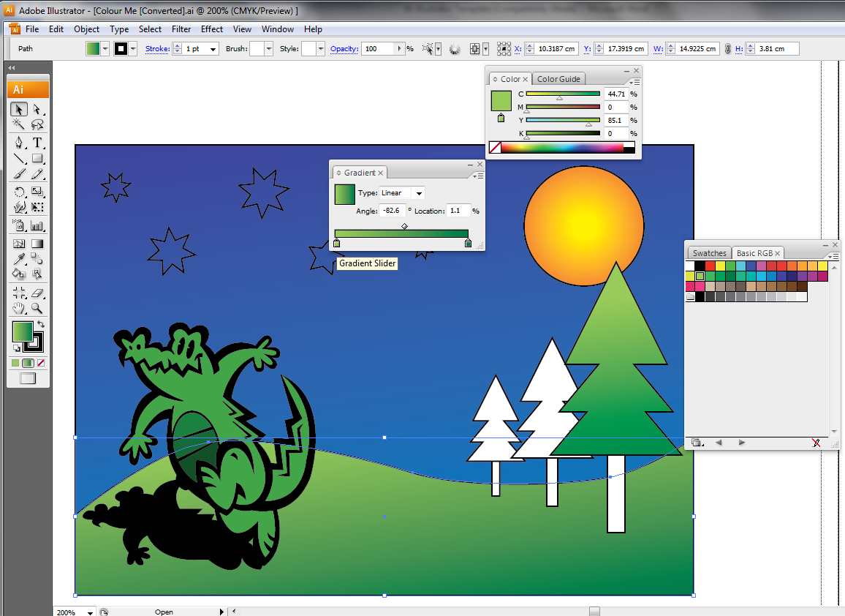

Look at the picture carefully and try to match all the colours
Change the eyes
Give his chest an new look
Remove all outlines

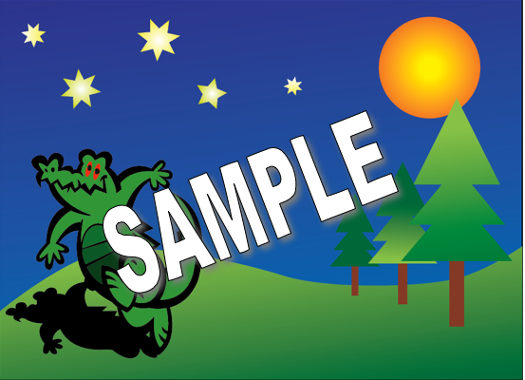

Now you can create your own scene, drawing or logo and add colours

Well done!
Save your work

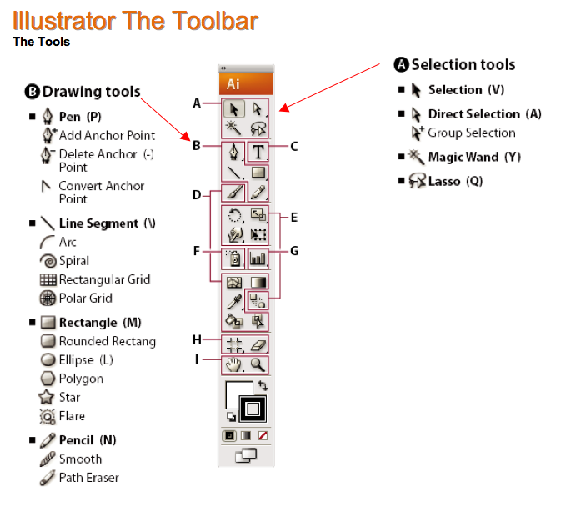

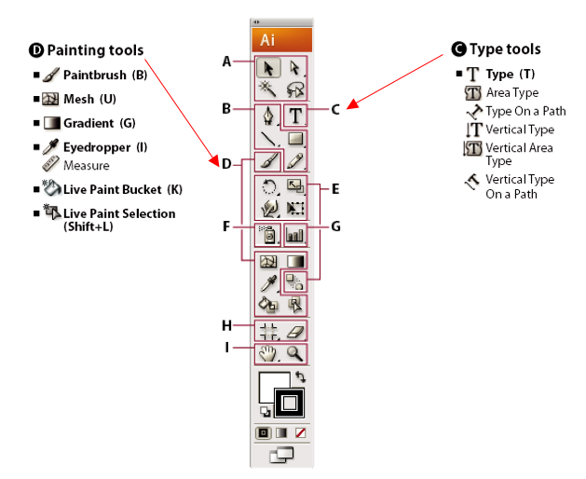

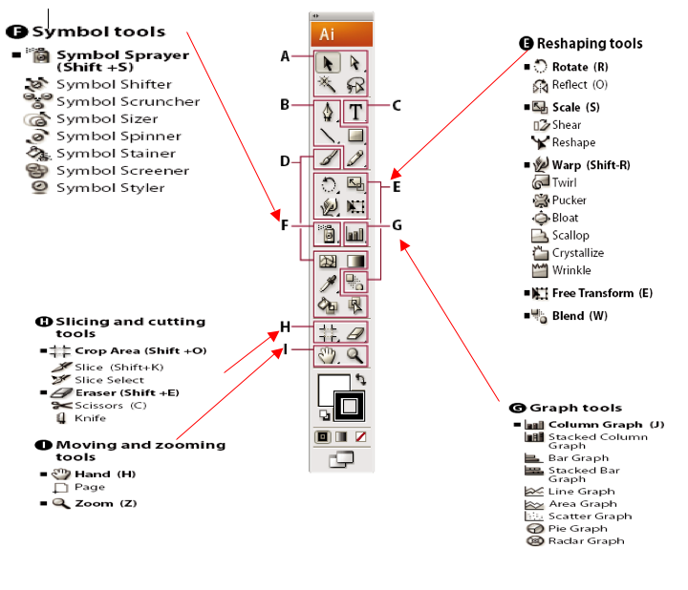

Adobe Illustrator Tips and Tricks
Masking with type Outlines
You can cut an object within the shape of any other object that has a path. First, draw the shape that will be the mould for the other object. Now position the other object over this one and select both the objects. Click on Object > Clipping Masks > Make.
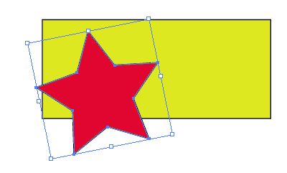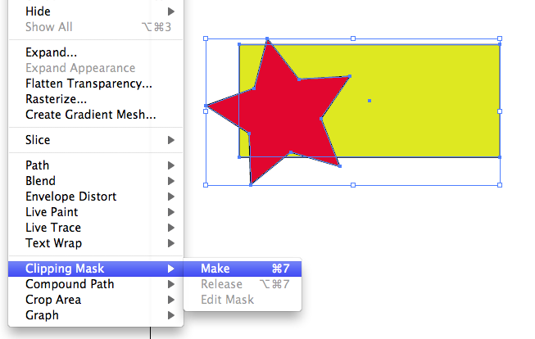
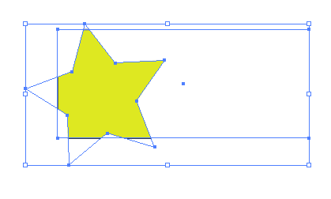
Changing Tool Pointer
You can change the appearance of the pointer from the tool pointer to a cross hair for more precise control. When the pointer is a cross hair, more of your artwork is visible. This is convenient for detailed drawing and editing. To make a drawing tool pointer appear as a cross hair, press the Caps Lock key before you begin drawing with the tool. To make this change permanent, open File > Preferences ? General/ Enable use Precise Cursor and click OK.
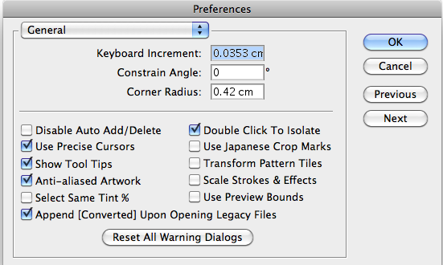
Draw Straight
When you draw or move objects, hold down the Shift key so as to affect it within a range of 45 degrees. this angle can be changed from File > Preferences > General. Enter the new Constrain Angle and click OK.

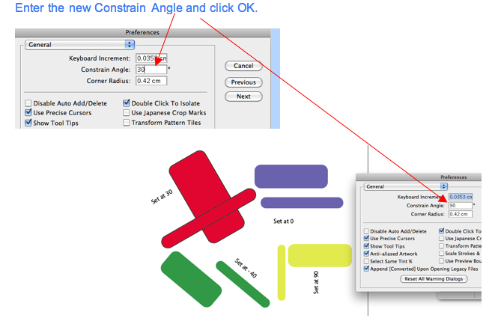

Scratch Disk
For best performance provide Illustrator with ample swap space on the hard disk where it can temporarily store information about the workspace, such as the image information, undo information, etc. this will ensure smooth functioning of the program, especially if you work with large, complex graphics. To change the location of the scratch disk, click on File > Preferences > Plug-ins & Scratch Disk.
View Print Colors
You can have Illustrator display colors on screen close to what they would look like when printed. Click on File > color Settings. Enable Simulate print colors on display. The colors will match more closely if the correct color profile is chosen for each device.
Easter Egg
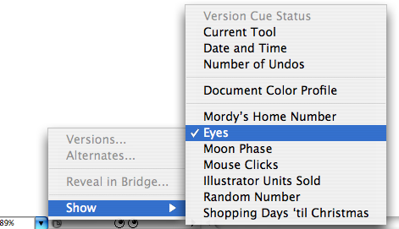
In the lower left hand corner of the drawing area, Illustrator by default displays the current tool being used. You can click on it to view other items, such as the Date and Time, the amount of Free Memory and the Number of Undoes. If you hold down the Alt key while clicking on the drop-down, you can choose items like number of shopping days left till Christmas, a pair of eyes that follow your cursor, the number of mouse clicks, the moon phase among other things!
Custom Brushes
To use an object as a brush, select the object and click on the new brush icon on the brushes palette. On the new brush dialog box, select the kind of brush to create and click OK. Set the properties for the brush from the Brush Options dialog box and click OK to create the brush
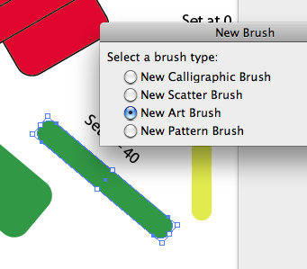
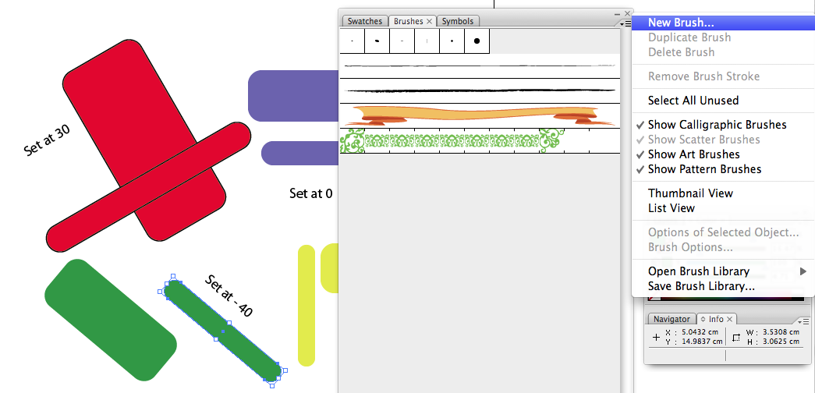
Object selected for new brush 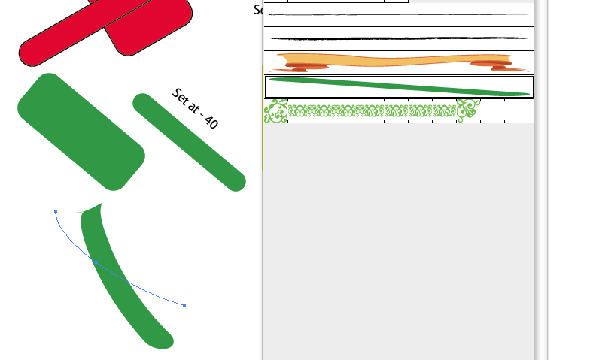
Using the new brush

Artwork and Preview
You can view some items in Preview mode and other items in Artwork more simultaneously. Place the objects on separate layers. Double-click the layers you wish to see in Artwork mode and disable Preview from the layer Options dialog box.

Looking and Hiding
To lock the hide items, by select the objects and click on Object > Lock or Object > Hide Selection. However, often it may be easier to lock or hide the items that are not selected, to do so, hold down the Alt key while clicking these menu items.
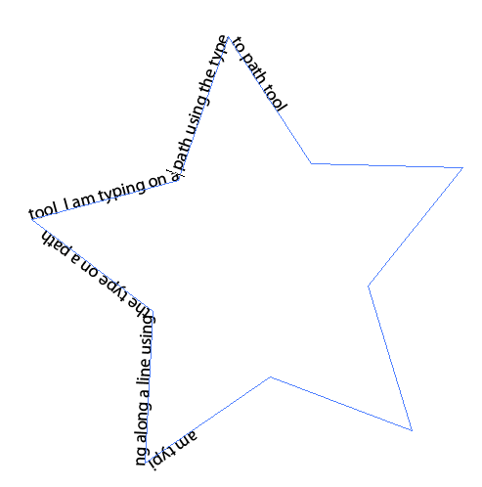

Text on Path
You can apply text around any object in Illustrator. First create the object around which you want the text to appear. Select the Path Type tool. To do so, hold down the mouse button on the Type tool until the options below it appear. Create in insertion point near the edge of the object and type the text.



